Seminar on Journal Article Writing: Session 1
Speaker: Dr. Anant R. Kukreti, Director for Engineering Outreach Professor
Ms. Amanda Sopko, 6th Grade Math Teacher at Indian Hill, RET Teacher 2015
Date: Friday, July 1, 2016
Time: 9-10 AM
Venue: University of Cincinnati, Swift Hall, Room 516

Prepared by:
Samuel Mizener, Kings High School, Kings Mills, Ohio
RET Participant for Project #4: “Cyberspace: Attack & Defense”

Dr. Anant Kukreti is Director for Engineering Outreach for the College of Engineering and Applied Science and Professor in the Department of Biomedical, Chemical and Environmental Engineering. He joined UC in August, 2000 as Head of the Department of Civil and Environmental Engineering (CEE) and before that worked for 22 years at University of Oklahoma, Norman, Oklahoma. After serving as the Department Head of CEE he was appointed as the Associate Dean for Engineering Education and Research in the College of Engineering and Applied Science in which capacity he served until August 2009. He teaches structural mechanics, with research in steel structures, seismic analysis and design, and engineering education. He has won five major university teaching awards, two Professorships, two national American Society of Engineering Education teaching awards, and is internationally recognized in his primary research field. He has extensive administrative experience in managing major NSF grants, which includes can ongoing $9 Million Math and Science Partnership grant, a $2 Million STEP grant, a $600,000 S-STEM grant, a $300,000 REU grant, and a $500,000 RET grant. He is also coordinating a $4.3 Million Choose Ohio First Scholarship grant from the Ohio Board of Regents.
Amanda Sopko has taught math for 13 years. Currently, she is coordinating the STEM program at Indian Hill Middle School and co teaching the 6th grade STEM class with a science teacher. Her masters degree is in Curriculum and Instruction and as a mathematics specialist she is leading the STEM team in providing STEM experiences for the middle school students at IHMS. She also advises the Future City Team. One team won the Georgia Regional Competition and competed at the national competition in Washington D.C. during National Engineering Week. She was voted Brooks County Middle School Teacher of the Year in 2010. Last summer, Amanda participated in the RET program at UC.
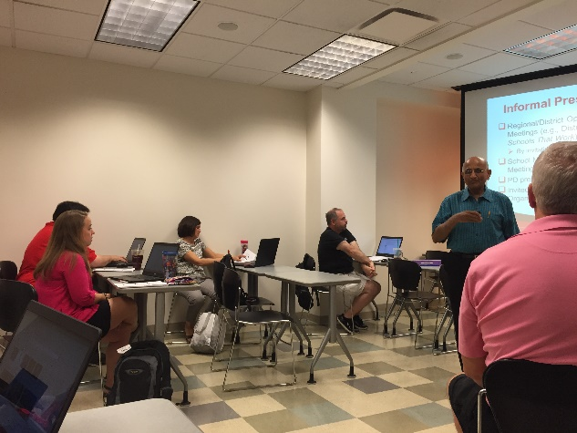
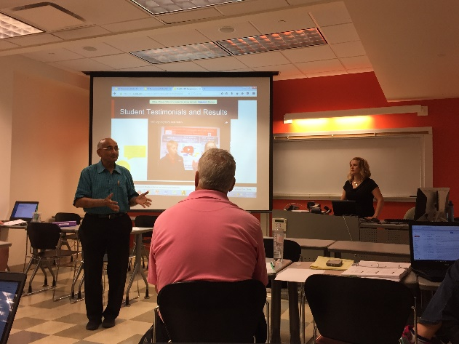
Figure 1: Dr. Kukreti review presentation techniques

Figure 2: Dr. Kukreti introducing Amanda Sopko

Dr. Kukreti began the session by explaining thoroughly the purpose of the seminar and how it
relates to the work that will be done by the RET teachers. Debbie Liberi passed out several materials that were used for reference throughout the presentation. These materials included a collection of Associations, Conferences, and Journals that were relative to the science and mathematics subjects. Dr. Kukreti encouraged the RET teachers to email him any additions to the collections that were not included. Also included was an editorial entitled, “Research Experience for Teachers: The Art of Formal Education”, “Elimination of persistent odorous compounds from drinking water”, “New Orleans Jazzed about Engineering Education”, “Chemical Connections: A Problem-Based Learning, STEM Experience”. All of these materials were referred to throughout the presentation.

The first topic that was covered was the difference between different dissemination opportunities. These types of publications and presentations could be formal or informal. Formal examples include a journal paper, magazine article, or a conference paper. Informal examples would include regional open forum conferences, school meetings, professional development presentation for other teachers, or presentations to civic groups or organizations.

Dr. Kukreti finished his portion of the seminar by giving specific instructions on presenting unit topics in a PowerPoint or poster presentation. He discussed the importance of an abstract to hook the audience in and make them curious about attending the presentation.

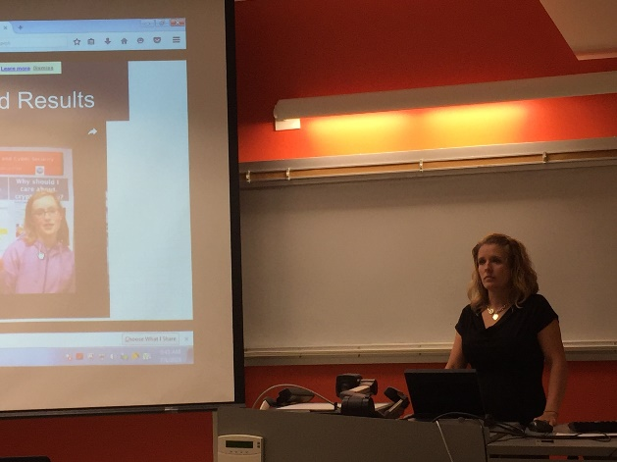

Figure 3: Amanda Sopko reviwing PowerPoint

Ms. Amanda Sopko presented her presentation outline. She presented at NCTM and the STEM Conference in 2016 so her outline was formatted in a way that gave the overall outline of her research work. Amanda showed her RET Cryptography Unit Video to the current RET teachers. The video was a great example of how to put a video together that summarizes the implementation of the unit video.

